Be careful what you say, agree with God instead!

“And Jephthah made a vow to the LORD, and said, “If You will indeed deliver the people of Ammon into my hands, then it will be that whatever comes out of the doors of my house to meet me, when I return in peace from the people of Ammon, shall surely be the LORD’s, and I will offer it up as a burnt offering.”

And he defeated them from Aroer as far as Minnith—twenty cities—and to Abel Keramim, with a very great slaughter. Thus the people of Ammon were subdued before the children of Israel.”
Judges‬ 11:30-31, 33‬ NKJV‬‬

“When you make a vow to God, do not delay to pay it; For He has no pleasure in fools. Pay what you have vowed— Better not to vow than to vow and not pay. Do not let your mouth cause your flesh to sin, nor say before the messenger of God that it was an error. Why should God be angry at your excuse and destroy the work of your hands?”
Ecclesiastes‬ 5:4-6‬ NKJV‬‬

“Above all we must be those who never need to verify our speech as truthful by swearing by the heavens or the earth or any other oath. But instead we must be so full of integrity that our “Yes” or “No” is convincing enough and we do not stumble into hypocrisy.”
James (Jacob)‬ 5:12‬ TPT‬‬

What do we learn from Japhaiths vow

1- Did God ask for the sacrifice/ vow

- what does the word of God say about the situation.
- What is your motivation for the vow (Glorify God/ or for personal gain)

“Make God the utmost delight and pleasure of your life, and he will provide for you what you desire the most.”
Psalms‬ 37:4‬ TPT‬‬

2- do we need to “make a deal”

- be careful the bows you make. Whatever you vow you must follow through
- God does not need a “deal” he has already promised
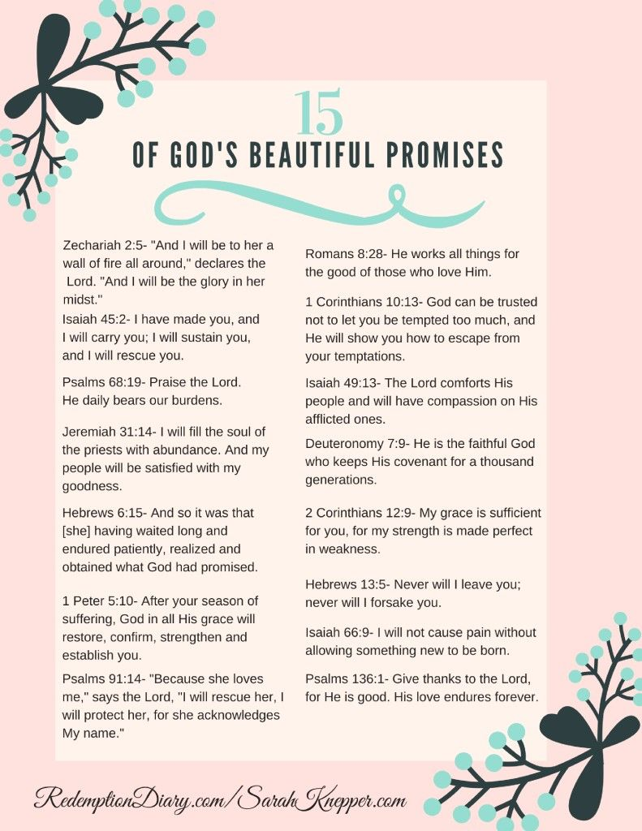

3- we need to be careful what we vow

- The power of life and death are in the tongue Proverbs 18:21

Death(maverick) from 4191; death (natural or violent); concretely, the dead, their place or state (hades); figuratively, pestilence, ruin:--(be) dead((-ly)), death, die(-d).

Life (chat) from 2421; alive; hence, raw (flesh); fresh (plant, water, year), strong; also (as noun, especially in the feminine singular and masculine plural) life (or living thing), whether literally or figuratively:--+ age, alive, appetite, (wild) beast, company, congregation, life(-time), live(-ly), living (creature, thing), maintenance, + merry, multitude, + (be) old, quick, raw, running, springing, troop.

Power( yad) a primitive word; a hand (the open one (indicating power, means, direction, etc.), in distinction from 3709, the closed one); used (as noun, adverb, etc.) in a great variety of applications, both literally and figuratively, both proximate and remote (as follows):--(+ be) able, X about, + armholes, at, axletree, because of, beside, border, X bounty, + broad, (broken-)handed, X by, charge, coast, + consecrate, + creditor, custody, debt, dominion, X enough, + fellowship, force, X from, hand(-staves, -y work

“Sharing words of wisdom is satisfying to your inner being. It encourages you to know that you’ve changed someone else’s life. Your words are so powerful that they will kill or give life, and the talkative person will reap the consequences.”
Proverbs‬ 18:20-21‬ TPT‬‬

God proclaims
Devil uses vows

